Evaluating AI Search
https://www.youtube.com/watch?v=wRJD0inpmjU
~ Prepared by Riya Kharade

- Introduction

Speaker: Julia, Diana, Mara – Quotient AI
Topic: Evaluating AI Search
Format: Talk with interactive Q&A
Purpose: Explain challenges, methods, and metrics for evaluating AI search systems, including static vs dynamic datasets, reference-based vs reference-free evaluation, and building reliable, real-time AI agents.

1. Introduction
This talk, presented by Julia, Diana, and Mara from Quotient AI, discusses the challenges and methods for evaluating AI search systems. The focus is on handling real-time AI agents, dynamic environments, and ensuring reliable evaluation in production systems.

2. Background
- Challenge in AI Monitoring: Traditional monitoring fails with modern AI because AI agents are dynamic, not following predetermined logic.
- AI Failure Modes: AI agents can hallucinate, fail in retrieval, make reasoning errors, often simultaneously and interconnected.
- Objective: Build production-ready AI search agents capable of handling unpredictable environments like real-time web data and diverse user queries.

3. What Real-Time AI Search Delivers Value
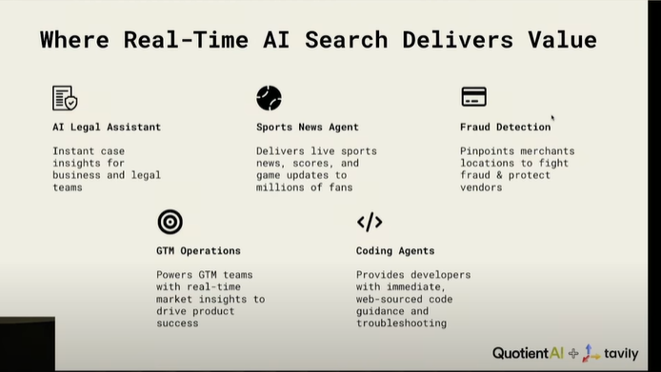
Real-time AI search can provide practical value in many domains:
- AI Legal Assistant: Supports legal/business teams with instant case insights.
- Sports News Agent: Delivers live scores, game updates, and news.
- Fraud Detection: Helps credit card companies identify merchant locations in real time.
- Coding & GTML Operations: Supports AI agents in development tasks.

4. Principles Guiding Our Evaluation
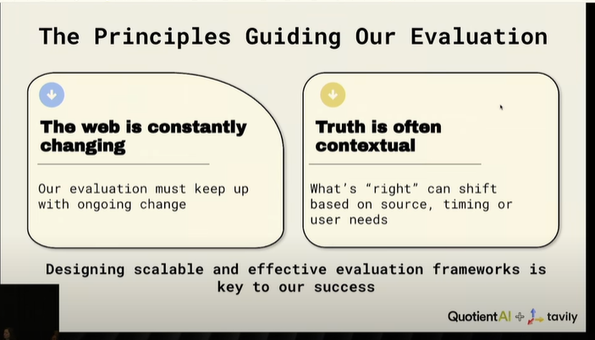
- Web is constantly changing: Evaluation must keep up with real-time updates.
- Truth is subjective & contextual: Correctness depends on source, timing, and user needs.
- Evaluation should be unbiased and fair, even when absolute truth is hard to define.

5. Static Datasets for Evaluation
- Simple QA: Short, fact-based questions with a single answer.
- Hotpot QA: Multi-hop questions requiring reasoning across multiple documents.
- Limitation: Static datasets cannot reflect evolving web content. Yesterday’s data cannot answer today’s questions.
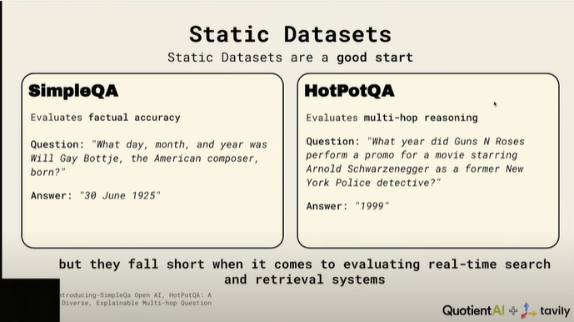
6. Dynamic Datasets
- Solution: Dynamic evaluation datasets that reflect real-time data.
- Advantages:
  - Real-world alignment
  - Broad coverage
  - Continuous relevancy (regularly refreshed)

7. Building Dynamic Evaluation Dataset for Web-Based RAG Systems
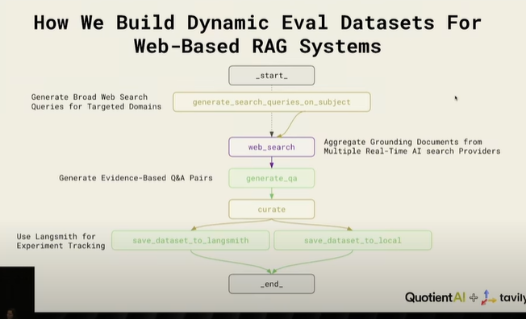
- Open-source agent: Generates dynamic datasets for AI search systems.
- Steps:
  - Generate broad web search queries for targeted domains.
  - Aggregate grounding documents from multiple AI search providers to minimize bias.
  - Generate evidence-based Q&A pairs ensuring reliability and reduced hallucinations.
  - Track experiments using Length Miss for observability over time.

8. Benchmarking Criteria
- Measure accuracy, source diversity, source relevancy, hallucination rate.
- Use unsupervised evaluation methods to scale evaluation without ground-truth labels.
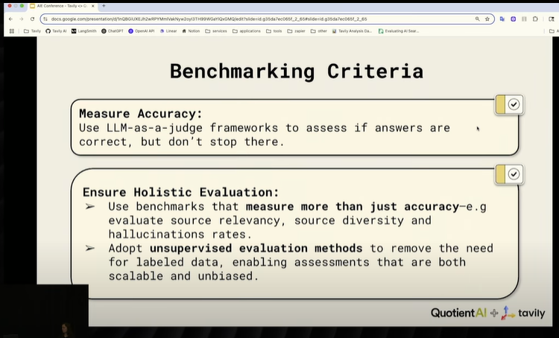
9. Static vs Dynamic Benchmarking
- Experiment: Compared six AI search providers on Simple QA (static) and dynamic benchmark (~1,000 rows).
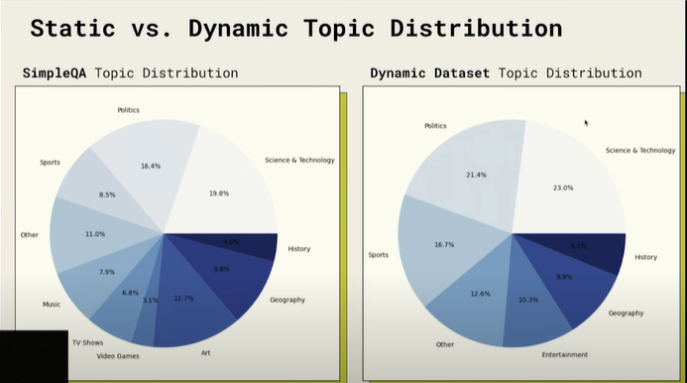
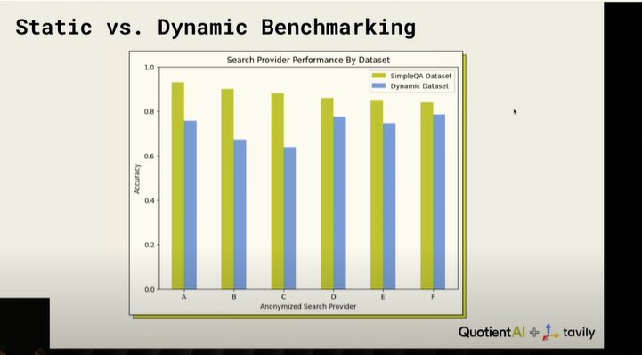
- Findings:
  - Dynamic benchmark accuracy lower than static.
  - Provider rankings can change significantly between static and dynamic datasets.
  - Indicates static benchmarks may miss real-world performance issues.

10. Flawed Evaluation
- Static benchmark (reference-based) may fail to detect hallucinations or partial correctness.
- Example: Some responses flagged incorrect actually contain correct answers; some correct ones may include hallucinations.

11. Reference-Based vs Reference-Free Evaluation
Reference-Free Metrics: Useful when ground truth is unavailable.
- Answer Completeness: Measures if all parts of a question are answered.
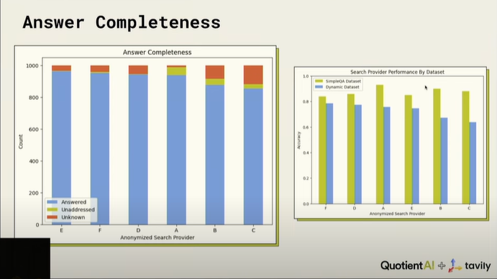
- Document Relevance: Percent of retrieved documents that are relevant to the question.
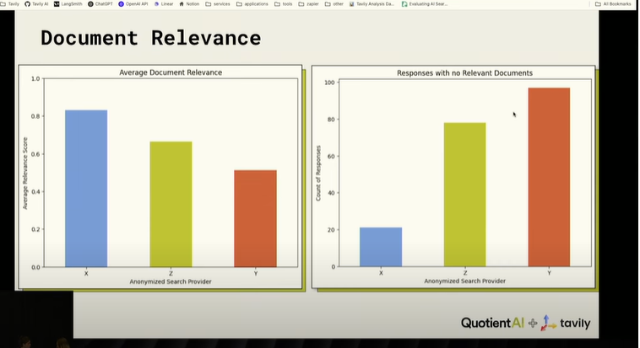
- Hallucination Detection: Identifies facts not present in the retrieved documents.
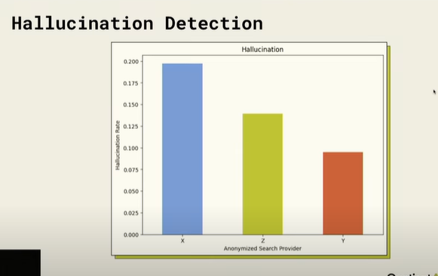
- Insight: Metrics work better together to identify issues, trade-offs exist (e.g., high completeness can increase hallucinations).

12. Metrics Working Together
- Evaluate multiple dimensions: completeness, relevancy, hallucination.
- Helps diagnose errors and strategize improvements (e.g., retrieve more documents, improve grounding).
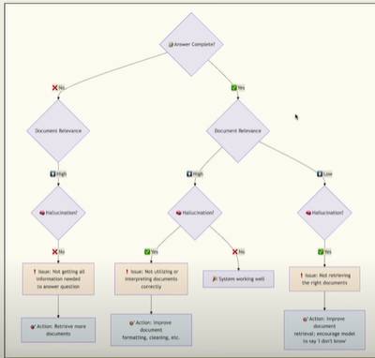
13. Building the Future of AI Search
- Goal: Self-improving AI systems
  - Detect outdated info
  - Identify unreliable sources
  - Understand user needs
  - Detect & correct hallucinations without human intervention
- Building blocks: Dynamic datasets, holistic evaluation, reference-free metrics.

14. Conclusion / Key Takeaways
- Static datasets alone are insufficient; real-time evaluation is essential.
- Dynamic datasets provide real-world relevancy and adaptability.
- Reference-free metrics complement reference-based evaluation.
- Evaluation should identify root causes of errors, not just rank performance.
- Future AI search should be self-improving, reliable, and continuously learning.

